If a context free grammar **G** has more than one derivation tree for some string **w ∈ L(G)**, it is called an **ambiguous grammar**. There exist multiple right-most or left-most derivations for some string generated from that grammar.

Problem

Check whether the grammar G with production rules −

X → X+X | X*X |X| a

is ambiguous or not.

Solution

Let’s find out the derivation tree for the string "a+a*a". It has two leftmost derivations.

**Derivation 1** − X → X+X → a +X → a+ X*X → a+a*X → a+a*a

**Parse tree 1** −

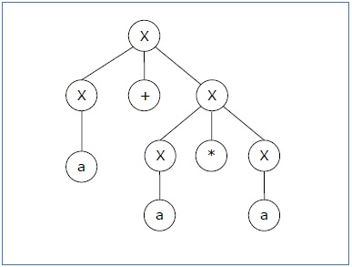

**Derivation 2** − X → X*X → X+X*X → a+ X*X → a+a*X → a+a*a

**Parse tree 2** −

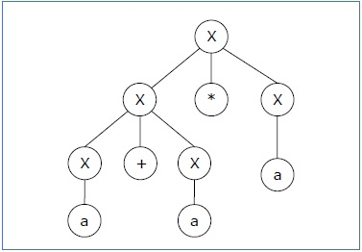

Since there are two parse trees for a single string "a+a*a", the grammar **G** is ambiguous.